Choose paper:

(Koç & Savaş, 2024)

References: (total is 86)

(Tai & Chen, 2023)

(Ayedoun et al., 2019)

(Dizon, 2020)

Time Cited: (total is 1)

(Septia et al., 2024)

Related Records:

(Tsui, 2020)

(Chapelle & Voss, 2021)

(Aydınlı & Ortaçtepe, 2018)

(Nassaji & Kartchava, 2021)

(Le Bruyn & Paquot, 2021)

Conceptual Mapping

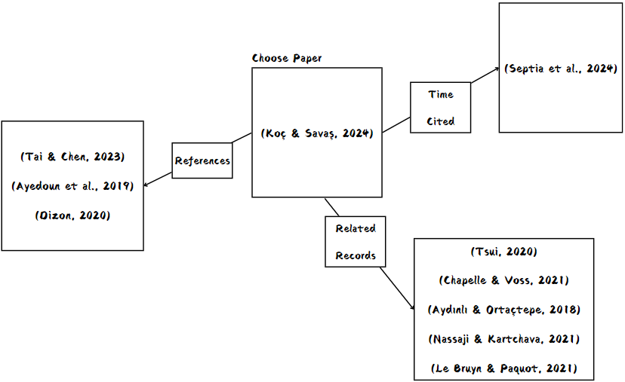

Papers:

Aydınlı, J., & Ortaçtepe, D. (2018). Selected research in applied linguistics and English language teaching in Turkey: 2010–2016. *Language Teaching*, *51*(2), 210-245. <https://doi.org/10.1017/S0261444818000010>

Ayedoun, E., Hayashi, Y., & Seta, K. (2019). Adding communicative and affective strategies to an embodied conversational agent to enhance second language learners’ willingness to communicate. *International Journal of Artificial Intelligence in Education*, *29*, 29-57. <https://doi.org/10.1007/s40593-018-0171-6>

Chapelle, C. A., & Voss, E. (2021). *Validity argument in language testing: Case studies of validation research*. Cambridge University Press. <https://doi.org/10.1017/9781108669849>

Dizon, G. (2020). Evaluating intelligent personal assistants for L2 listening and speaking development. *Language Learning & Technology*, *24*(1), 16-26. <https://doi.org/10125/44705>

Koç, F. Ş., & Savaş, P. (2024). The use of artificially intelligent chatbots in English language learning: A systematic meta-synthesis study of articles published between 2010 and 2024. *ReCALL*, 1-18. <https://doi.org/10.1017/S0958344024000168>

Le Bruyn, B., & Paquot, M. (2021). *Learner corpus research meets second language acquisition*. Cambridge University Press. <https://doi.org/10.1017/9781108674577>

Nassaji, H., & Kartchava, E. (2021). *The Cambridge handbook of corrective feedback in second language learning and teaching*. Cambridge University Press. <https://doi.org/10.1017/9781108589789>

Septia, F., Khodr, T. S. a. I., & Ilah, N. (2024). Unlocking AI's Potential in Language Learning: A Comparative Study of Adoption and Effectiveness in Indonesia and Arab Countries. *Language, Technology, and Social Media*, *2*(1), 60-71. <https://doi.org/10.70211/ltsm.v2i1.78>

Tai, T.-Y., & Chen, H. H.-J. (2023). The impact of Google Assistant on adolescent EFL learners’ willingness to communicate. *Interactive Learning Environments*, *31*(3), 1485-1502. <https://doi.org/10.1080/10494820.2020.1841801>

Tsui, A. B. M. (2020). *English language teaching and teacher education in East Asia: Global challenges and local responses*. Cambridge University Press. <https://doi.org/10.1017/9781108856218>